--**Refferential integrity constraints :** useful to define relation between tables.

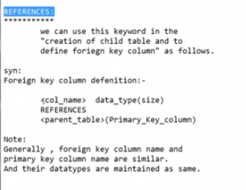

-- why we need Refferential integrity constraints ?

-- we get a clarity if we know about Normalization and Denormalization concepts.

Denormalization : maintaining all information in single big table

Normalization : maintaining all information in multiple table.

FK contains duplicates and null values.

PK does not contains duplicates and null values.

Parent / master / base table.

Child / derived / detailed table.

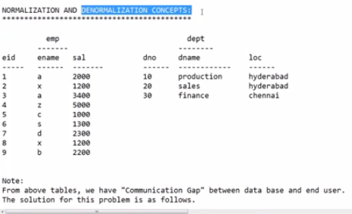

Here we can not find the relation between 2 tables because of communication gap.

We are unable to answer the following questions.

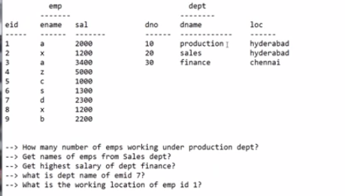

Only reason is , there is no relation between these 2 tables.

To eliminate communication gap,

First solution is Denormalization

Second solution is normalization.

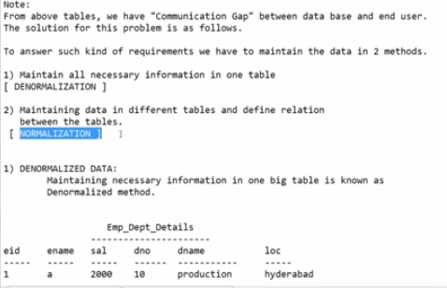

Denormalization :

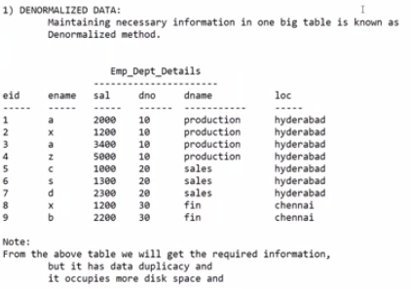

Necessary info means… actually employee belong to some department , should be mentioned.

**Drawbacks:**

It has more data than normalization / data duplicacy

Takes more search time

Occupies more disk space

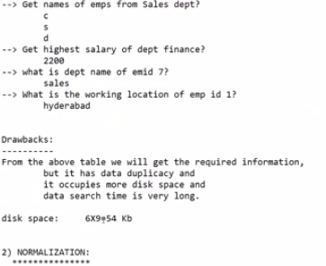

We can eliminate above drawback in normalization until max duplicacy reduces.

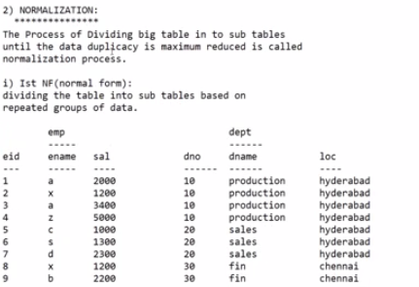

But here one record is repeating multiple times.

So eliminate duplicate records and define primary keys in 2nd normalization form.

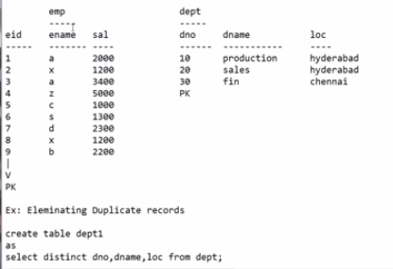

Here we don’t have complete information, no relation between 2 tables.

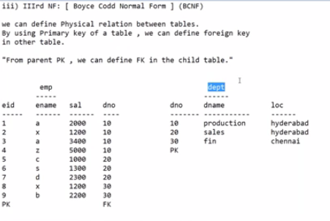

By using primary key in one table , we define foreign key in other table.

But we get a doubt , in which table we need to give primary key and in which table we need to give foreign key.

Here Parent table should have Primary key and Child table should have Foreign key.

But we should be careful which is parent table and which is child table.

Parent - child examples

Customer – bank account

Customer and product also parent in amazon site.

After Normalization and Denormalization we are able to get answers for above question.

But Normalization has advantages over denormalization.

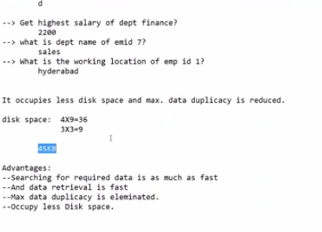

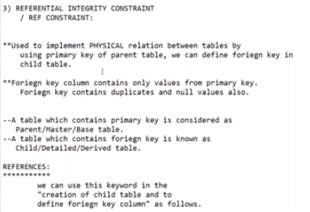

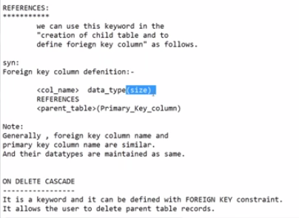

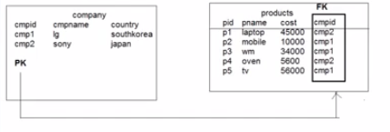

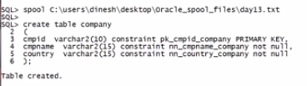

We should maintain same datatype for both PK column and FK column.

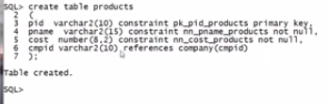

First we should insert values into parent table otherwise child table data cant be installed.

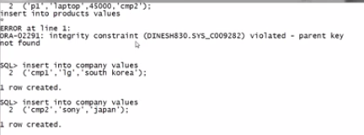

FK column accepts duplicate values and null values also

